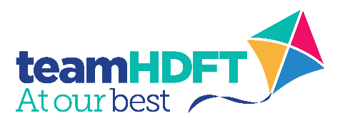
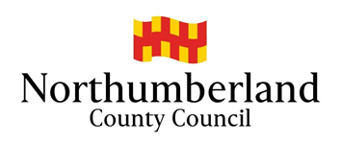
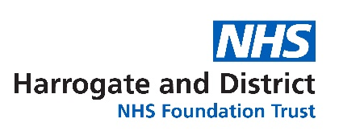

Harrogate District Hospital
Lancaster Park Road
Harrogate
HG2 7SX

T: 01423 885959
E: hello@hdft.nhs.uk
W: www.hdft.nhs.uk
28.9.21

Dear Colleague,

We are delighted to let you know that Harrogate and District NHS Foundation Trust (HDFT) has entered into a partnership with Northumberland County Council and will be providing Northumberland’s 0-19 Healthy Families Service from 1st October 2021.

HDFT is committed to providing effective 0-19 services in all of the communities that we work. As the biggest provider of 0-19 services in the UK (we currently operate this service for County Durham, North Yorkshire, Middlesbrough, Darlington, Stockton, Sunderland and Gateshead), we take great pride in providing the highest possible levels of care for children, young people and their families.

We care very much about being able to support our colleagues to help children, young people and their families get the best start in life. We have had the opportunity to meet a number of colleagues from the current service already and are really looking forward to working with them, Northumberland County Council and with you in the interest of all the communities across Northumberland. We would like to reassure you that all of the 0-19 Healthy Family Services Team will continue in their roles, ensuring there is no disruption to the service.

We know that the service is already of a high standard and is well regarded, and we intend to build on this by working with the 0-19 team, Northumberland County Council, and key partners. As such, we would welcome your views about key priorities from your perspective.

Due to the issues that society has faced over the last eighteen months, 0-19 services will now be more important than ever before. Whilst for many it may feel like the effects of the pandemic are reducing, we know that this isn’t the case for 0-19 services which are still dealing with high levels of safeguarding, more families needing targeted support, and the ongoing consequences from lockdown on vulnerable children and families.

The Northumberland 0-19 Healthy Families Service will work in partnership with other agencies to deliver coordinated care to children, young people and families, and will be integrated into the Northumberland County Council’s overall offer and objectives.

We look forward to working together to develop integrated pathways and sharing information to ensure that children, young people and families experience a seamless service.

If you would like to get in touch to discuss our new role of provider of 0-19 Healthy Families Services then please email hdft.northumberland0-19@nhs.net or contact Suzanne Lamb by emailing suzanne.lamb@nhs.net or calling 07392 194451.

Yours sincerely,
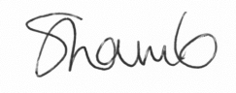
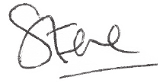

Steve Russell Suzanne Lamb
Chief Executive Head of Safeguarding HDFT,
#hellomynameis Steve Head of Nursing Community and Children's Directorate

